Find Best Neighborhood in Shanghai to Build Electrical Vehicle Charging Station

Shuhao Constan Chang

1. **Introduction and background**

This is a real problem I met when I was an intern in a nation owned new energy company in Shanghai three years ago. At that time, the government decided to provide a large amount subsidy for new electrical cars. Customers were willing to buy electrical cars, but they were concerned about the very limited small electrical charging sites could not satisfy their charging demand when new energy cars getting more. This issue limited the development of new energy cars in Shanghai. Our company need to make decisions to select two neighborhoods as the first stage of building stations plan.

Electrical vehicle charging stations are completely difference with gas stations. The most important thing is that charging a vehicle takes far longer time that filling gas to a car. A 90% charging process will usually take more than 4 hours, but filling gas only takes less than 10 mins. And electrical charging stations are much larger than gas stations, since a lot of cars need to be charged at the same time.

Based on these features, an ideal place to build an electrical vehicle charging stations should have below characteristics: 1. People tend to choose drive to this location. 2.People usually stay at this neighborhood for more than 4 hours once (shopping, traveling and hoteling are typical activities for longer stay). 3. The neighborhood should not be in but near the downtown area, which is feasible and cheap to find an open area to build a large station.

At that time, the company used traditional statistical marketing model to make decisions on where to build the station. Now I am going to use K-means and data analyze to find the good places to build the station.

1. **The data and information used for analyzing**
   1. The divisions and neighborhoods of Shanghai

These data and information will be scraped from Wikipedia web page

<https://en.wikipedia.org/wiki/Category:Neighbourhoods_of_Shanghai>

* 1. Geographical coordinates (Latitude and longitude) data of each neighborhood

This data is import from Geocoder library

<https://geocoder.readthedocs.io/>

* 1. Venues data in each neighborhood.

This data is acquired from Foursquare API

<https://foursquare.com/>

1. **Methodology and Main Components**
   1. Install and Import Libraries

The library I used in this project: beautifulsoup4, geocoder, numpy, pandas, json_ _normalize, geopy, requests, matplotlib, sklearn-Kmeans, folium, geocoder

* 1. Build a dataframe of neighborhoods in Shanghai, China by web scraping (BeautifulSoup) the data from Wikipedia page

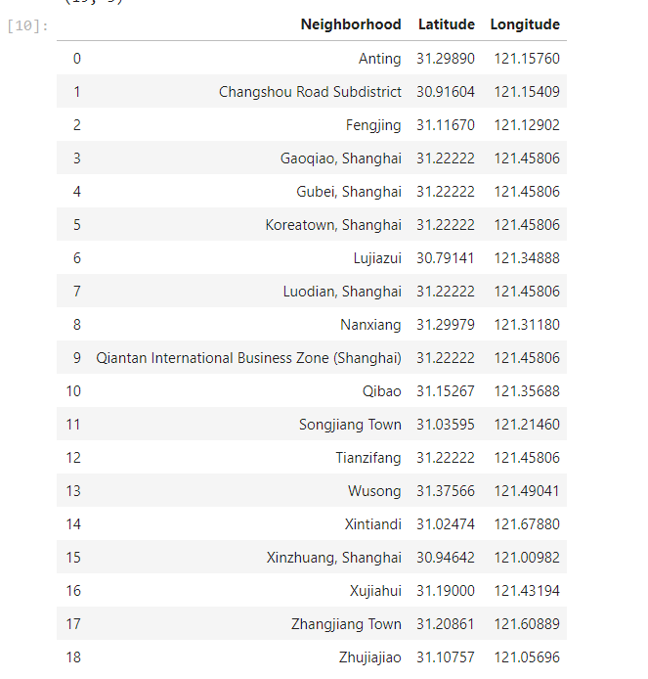

Firstly, find a systemic introduction of neighborhoods from Wikipedia and implement BeautifulSoup to scrap data from webpage. Then, create a data frame to store these neighborhoods.

* 1. Get the geographical coordinates (Geocoder) of the neighborhoods and build a map with neighborhoods

Define a function to get coordinates, initialize variable to None and loop until getting the coordinates. Create temporary data frame to populate the coordinates into Latitude and Longitude. Merge the coordinates into the original data frame. Check the neighborhoods and the coordinates and finally create map of Shanghai using latitude and longitude values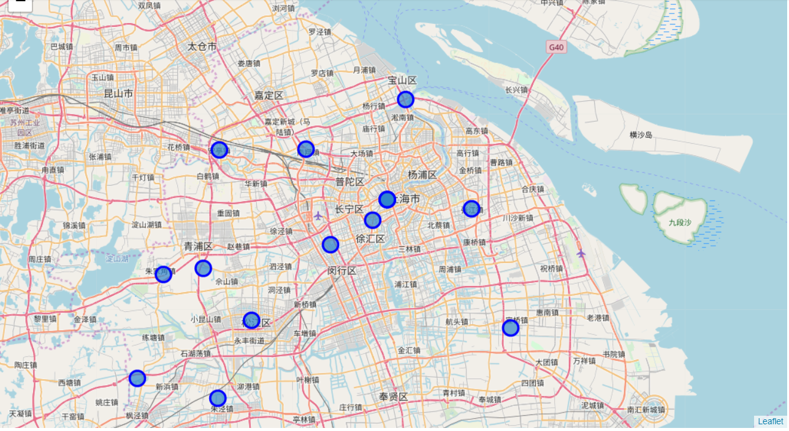

* 1. Obtain the venue data for the neighborhoods from Foursquare API and categorize the venues by parking time length

Define Foursquare Credentials and Version. Download venue information in each neighborhood via Foursquare API. Convert the venues list into a new data frame and combine with data frame of neighborhoods. Count the number of main venue types with descend order and select top-10 venue types by numbers for data analyze. Then categorized data into three types with different general parking time. Note that in these venue types, "Shopping Mall, Hotel, Park" are venues longer parking hours

"Spa, Dumpling Restaurant, Chinese Restaurant, Japanese Restaurant" are venues Medium parking hours "Cocktail Bar, Bakery, Coffee Shop" are venues shorter parking hours or no parking places. Then cluster the neighborhoods by above venue characteristics by Sklearn Kmeans with k=3 and random_state=0. Then create a new data frame that includes the cluster as well as the top 10 venues for each neighborhood with latitude and longitude data. Use this result data frame to create a new map with clusters in different color.

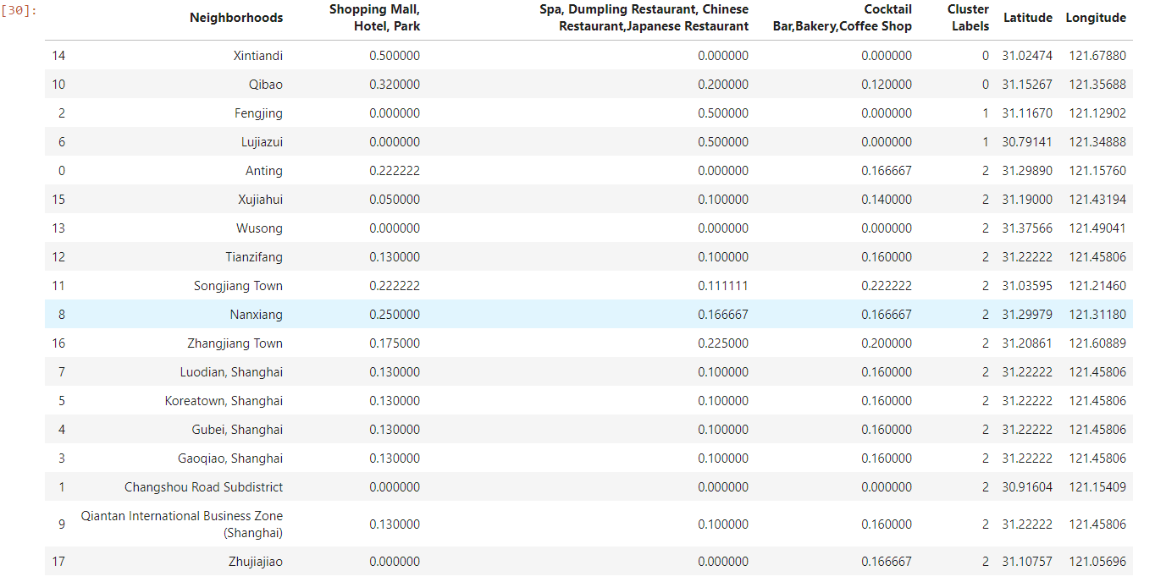

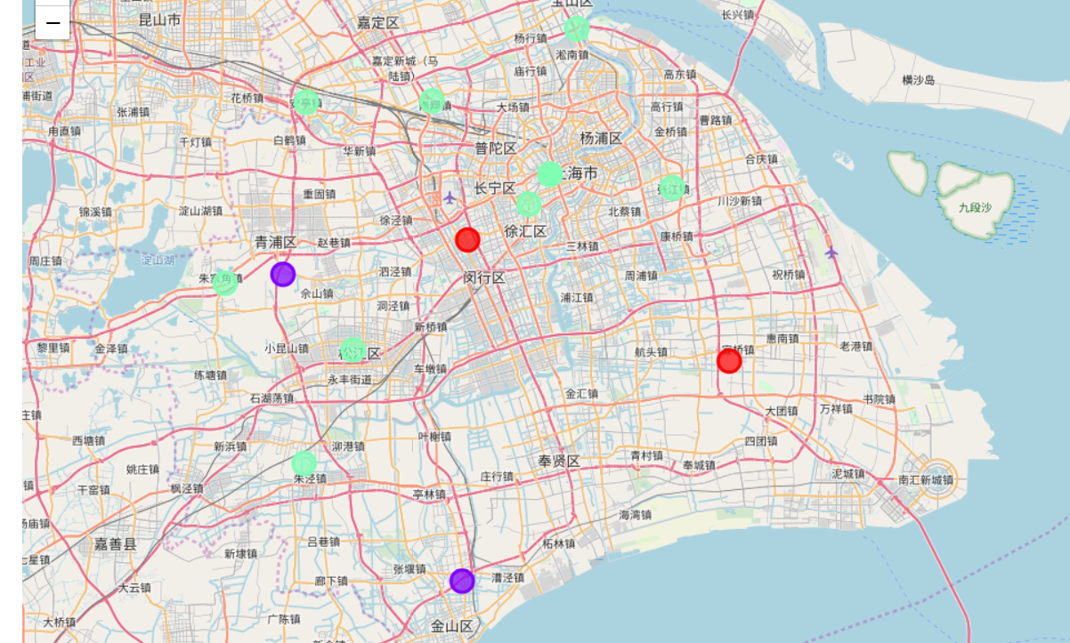

1. **Analyze the result and make decision**

From above clustering result, cluster 2 are neighborhoods where longer, medium and shorter parking time places are relatively in average number. These neighborhoods are usually downtown neighborhoods. All kinds of business overlapped with each other, parking space are usually limited, and public transportations are usually the first priority for people in Shanghai. Cluster 1 are usually residential area, the most popular business here are restaurants, these small restaurants are closed to living area, most of these restaurants do not provides parking spaces. Electrical cars owner will prefer to charge their cars in their own parking lot. Cluster 0 has high occurrence of Shopping Mall, Hotel, Park. These neighborhoods are a kind of away from downtown places, and the public transportation are not covered thoroughly. People will choose drive to these neighborhoods and usually stay for rather a long time. These neighborhoods are prefect places for building electrical charging stations. In conclusion, the neighborhoods to build electrical charging stations are Xintiandi, Qibao (cluster 0).

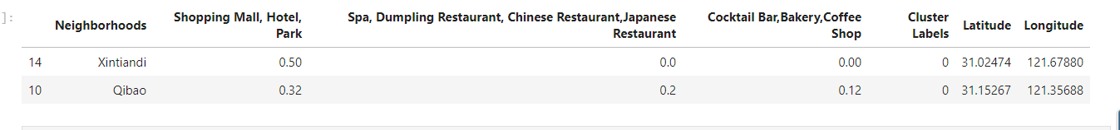

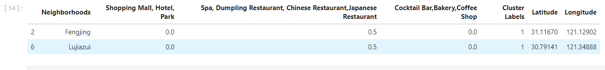

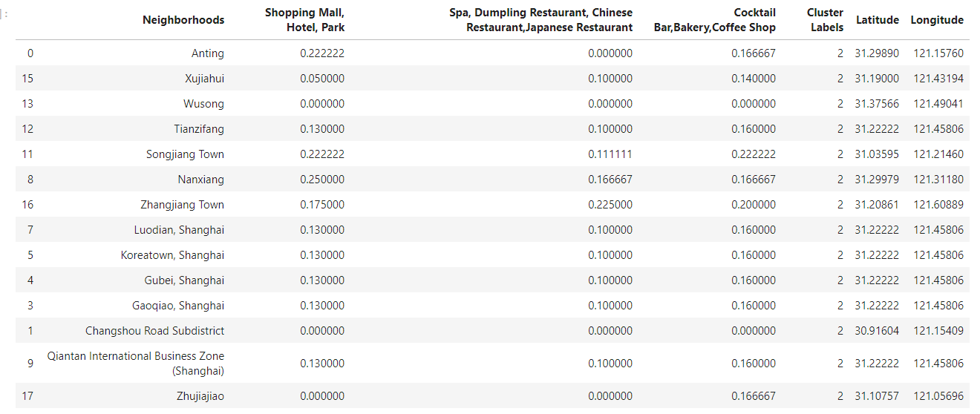

1. **Discussion**

Since this result is only the first stage of building two charging stations. However, two stations can not fulfill the demand of car charging in Shanghai. Once budget and human resource are available, the next stage with more location need to be considered. From above result, in stage two, we should move to cluster 2 to find new neighborhoods. The higher normalized value in Shopping Mall, Hotel, Park should be preferred to build new charging station. For example, Anting, Songjiang Town, Nanxiang are good choice for stage two charging station building.

1. **Conclusion:**

In the first stage, the neighborhoods to build electrical charging stations are Xintiandi, Qibao. In the second stage, Anting, Songjiang Town, Nanxiang are good choices to build electrical charging stations.